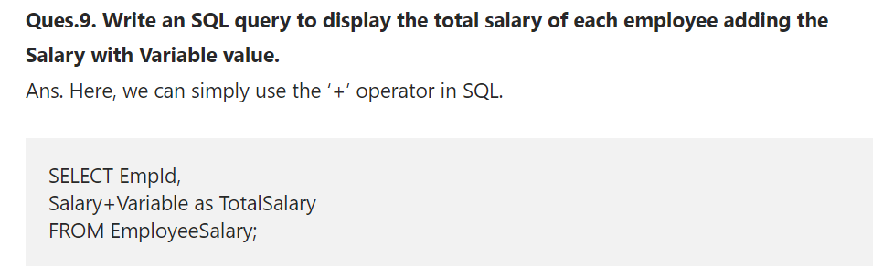

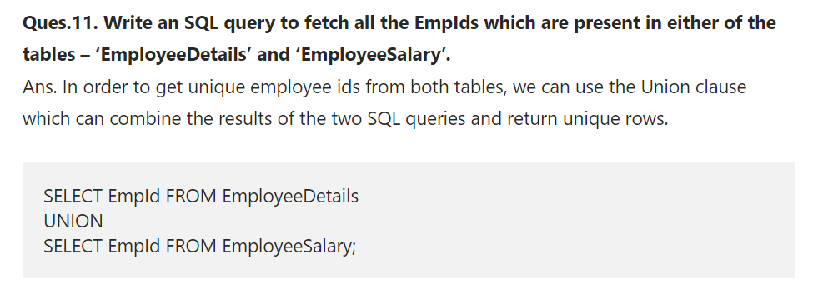

q) find empid present in one table which are not present in other table without join

select empid from empinfo where empid not in (select empid from empsalary )

